The goal for this project was to make a remote-controlled chassis with an effector, but to do so without a microprocessor. Hence all logic was hard-wired in the electrical connections between components, rather than programmed using code. In addition, I challenged myself to use the Internet only for datasheets. I did use two books for guidance. My roommate allowed the usage of a chassis with two Pittman gearbox motors setup for tank drive and a Dual VNH3SP30 Motor Controller, item #MD03A from Pololu. The project had five main phases:

* Achieve PWM control for variable speed of drive motors
* Interface an RC remote for speed and direction control of drive motors
* Develop a stepper motor controller
* Interface the RC remote for stepper motor controller
* Electrical Assembly
* Mechanical Assembly and Laser Pointer End Effector Mounting

# Phase One: PWM Control for Variable Speed of Drive Motors

The MD03A includes two H-bridges which allow for on/off and direction control of two DC motors. PWM inputs can control the speed. Initially, I experimented with a 555 timer in several configurations based on recipes 16.8 and 16.9 in Simon Monk’s Electronics Cookbook (O’Reilly, 2017) and Example 6, Chapter 4 in Alvis Evans’ Basic Digital Electronics (Master Publishing, 1996). A potentiometer controlled the duty cycle with diodes incorporated to allow for a full range of duty cycles. However, when testing with a Osepp 25mm DC motor and a L293D H-bridge (per recipe 13.3 in the same book), I found that neither circuit resulted in a nice linear response in motor speed the way I’d expect from the PWM outputs on a microprocessor.

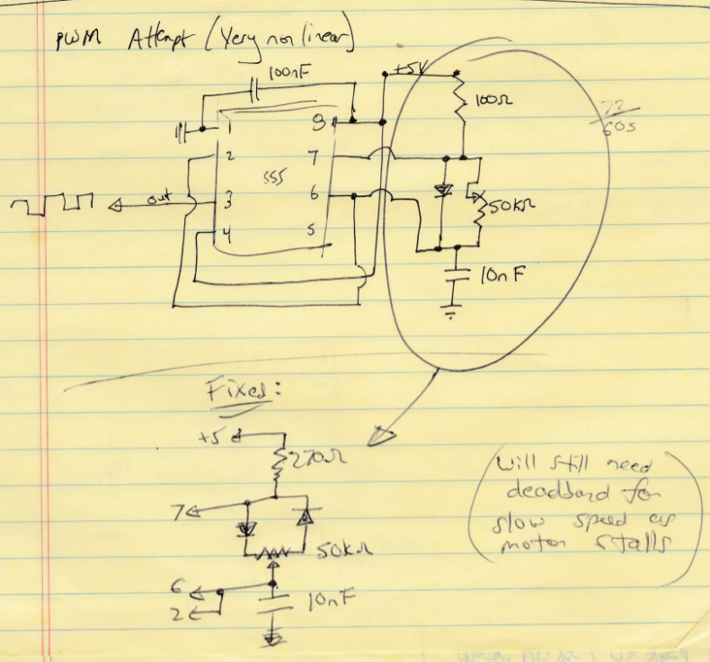

Figure : PWM Attempt #1 with 555 timer.

For Figure 1, the calculated PWM frequency was about 10kHz.

In Figure 2, a 32kHz clock is fed to a second 555 which has an analog control voltage fed to the Control pin. The graph in the top right corner shows the result, which included a sharp drop in voltage from 5V to about 3.8V followed by a more linear decrease as the control potentiometer was turned.

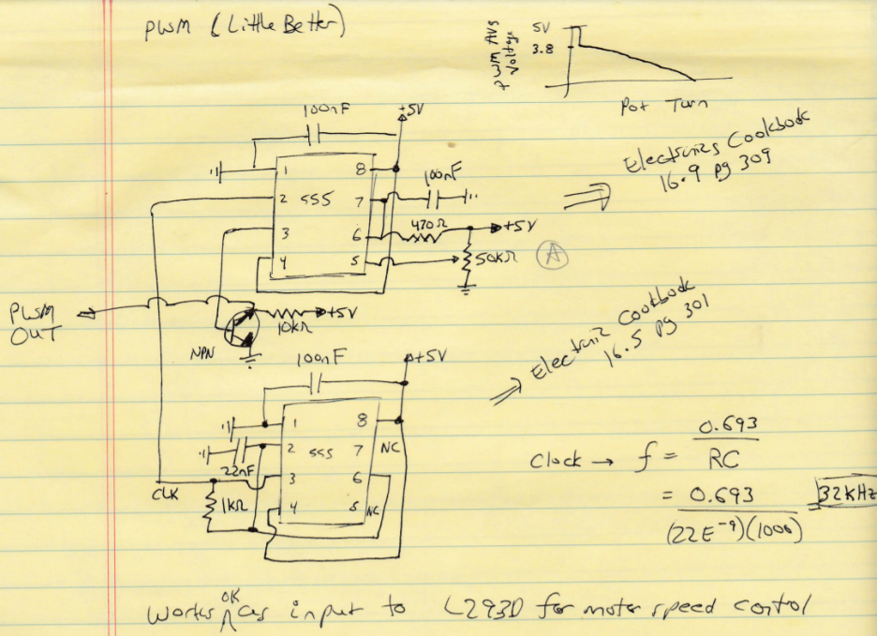

Figure : PWM Attempt #2 with 555 timers.

When the 555 PWM attempts didn’t come to fruition, I tried out a PWM control chip, the 1729 from NTE which I picked up at Fry’s. The 1729 is pin compatible with Texas Instrument’s TL494 chip which has a decent datasheet. The block diagram for this chip is shown in Figure 3.

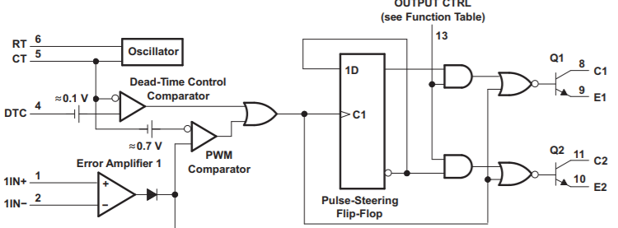

Figure : NTE1729 block diagram

An analog voltage is compared to a sawtooth oscillator to generate PWM. I didn’t used the error amplifier at all. The oscillation frequency is controlled by pins 5 and 6 :

$f_{osc}=\frac{1}{0.817×R×C+1.42{×10}^{-6}}$ ~ 3.7kHz. This chip has two outputs with available emitter/collectors for each. I grounded emitter 1 (pin 9) and pulled collector 1 (pin 8) high. The specifications sheet for the 1729 chip lists a maximum duty cycle of about 50% when the Dead Time Control (DTC, pin 4) is at 0 V. The minimum duty cycle 0% is when pin 4 is at about 3 Volts.

However, the output transistor Q1 functions as an inverter when used as an open collector. Figure 4 shows the inverted PWM output at two different voltages of the Dead Time Control pin. The DTC voltage is compared with an internal sawtooth oscillator output. When DTC is higher, the collector is pulled high. When DTC is lower, the output transistor is on and the collector is grounded via the emitter.

Figure : PWM output generation.

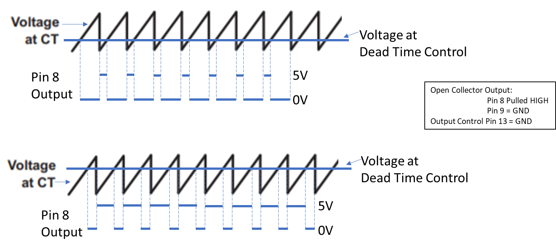

With my setup, when DTC = 3.3V, the output voltage is 5V (100% duty cycle). When DTC = 0V, the duty cycle is close to zero. A voltage of ~0.1V in series with DTC means the actual minimum duty cycle is always above zero.

There are two modes controlled by pin 13… single ended/parallel or push-pull. When pin 13 is grounded, the pulse steering flip-flop is disabled as the two AND gates output LOW… both Q1 and Q2 get the same signal from the Dead-Time Control Comparator. When pin 13 is HIGH, each rising pulse of the PWM signal switches the transistor which is activated. In my trials, I didn’t know this (because the NTE datasheets are terrible!) and left pin 13 floating (=bad design!). I would guess the chip is acting in single ended/parallel mode but I’m not sure.

I used a voltage divider with a 1k pot in series with 680 Ohm to 5V to generate a calculated range of 0 – 1000/1680 x 5V = 0 – 3 Volts as the input to the DTC pin. The output from pin 8 was run to the PWM input of a L293D. Direction control was provided by a mechanical slide switch. The motor responded smoothly and linearly to the input PWM, although it whined appreciably at low duty cycles as it was stalled. See Figure 5 for the setup.

To eliminate the stall, a deadband is typically used. With a microprocessor we compare the absolute value of the desired power to a threshold; if power is less than the threshold we set the power to zero:

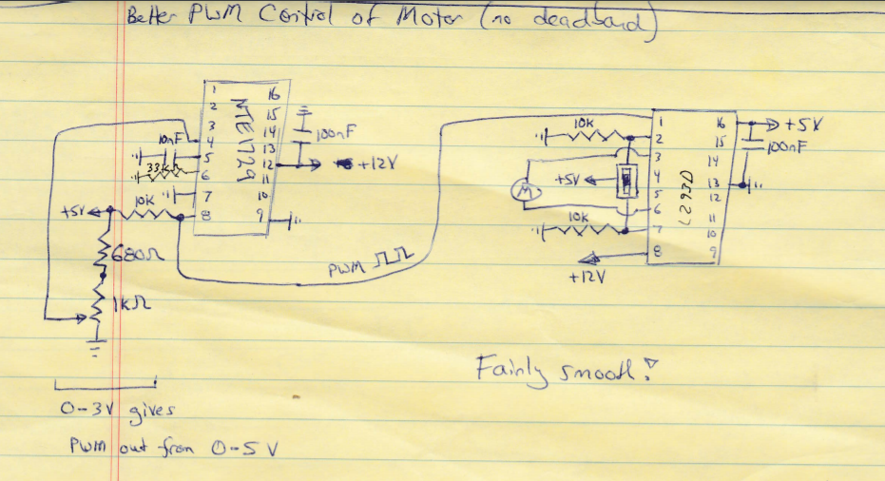

Figure : NTE1729 PWM output into L293D H-bridge.

if(abs(power) < threshold) { power = 0; }.

The equivalent in digital electronics is to use a comparator, which outputs a digital high or low signal based on a comparison of two inputs. The comparator output is then ANDed with the PWM signal. Figure 6 shows an early attempt at deadband control with an LM311 comparator and a 4081B AND gate.

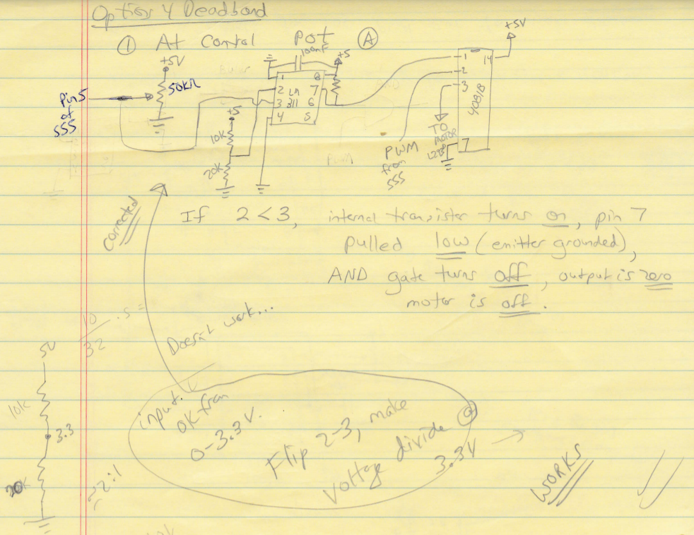

Figure : Deadband control using an LM311 comparator.

Putting all the work together, Figure 7 shows a working PWM controller based on the NTE1729 chip. The AND gate was implemented with three discrete MOSFET transistors (2N7000s).

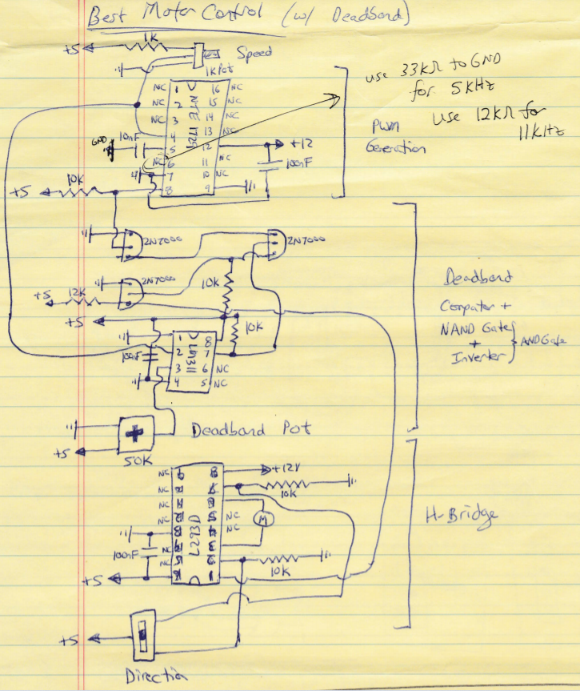

Figure : Speed controller based on NTE1729 including deadband logic.

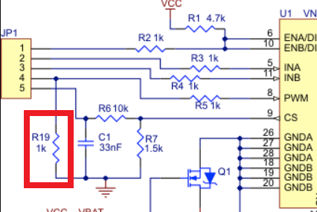

Figure : Pulldown resistor on PWM.

Finally, I tested the 1729 chip feeding PWM to the #MD03A from Pololu. At first, nothing happened, until I used a buffer between the two chips. The [schematic](https://a.pololu-files.com/picture/0J411.628.png?78fc551ac6ef5b54b366dcd33af0fe30) for the MD03A shows that the PWM pins are pulled down to GND with 1k pulldown resistors.

Conversely, the open collector outputs on the 1729 require a pullup resistor. With the line being simultaneously pulled up and down, the PWM voltage is in no-man’s land (although I would think the much larger 12k pullup would dominate?). A buffer ensures that each line is only pulled up or down. For this test, I used an AND gate with one input permanently set HIGH as shown in Figure 9.

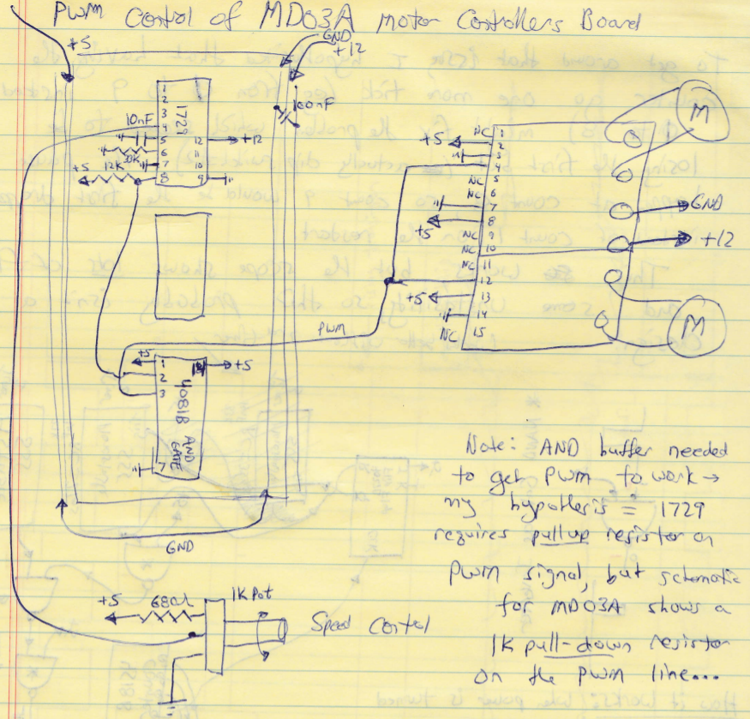

Figure : NTE1729 driving Pololu MD03A motor controller.

# Phase Two: RC Control for Variable Speed of Drive Motors

In Phase One, I learned how to using digital electronics to control the speed of a motor including a deadband. However, I wanted an untethered vehicle, and I also needed to figure out how to control the direction of rotation for the motors. Remote control (RC) units are ubiquitous and seemed like the best control device to use. Typical RC receivers output the control signal for a servo… this is a pulse whose duration sets servo position. Pulses range in duration from 500 – 2500us with a delay of 20ms between pulses. Designing a timer to read the pulse duration was way beyond my ability. Instead, I thought that the RC signal could be filtered and smoothed to result in an analog voltage.

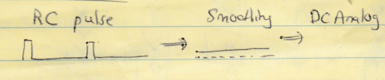

Figure : Converting RC servo pulse to DC analog.

To test this idea, I used a 555 timer to create a test servo pulse, filtered the signal and read the DC voltage on an oscilloscope and a multimeter.

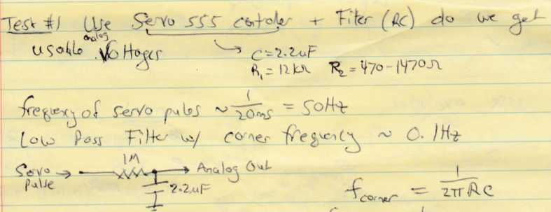

Figure : Test setup for converting DC servo pulse to analog.

The oscilloscope showed a flatline over all relevant timescales, while the multimeter showed a range of DC voltages from 0.16 to 0.41V. I initially hoped to translate/scale that voltage range… eg 0.16 – 0.41V 🡪 0 -3V input for NTE1729. But in talking with others, I was told that I should use comparators to test for discrete ranges which would represent speed/direction combinations. Figure 12 shows the idea.

|  |  |  |
| --- | --- | --- |
| **Voltage Range** | **Speed** | **Direction** |
| 0.16 – 0.201 | Fast | CCW |
| 0.201 – 0.243 | Medium | CCW |
| 0.243 – 0.285 | Slow | CCW |
| 0.285 (Midpoint) | Stop |  |
| 0.285 – 0.327 | Slow | CW |
| 0.327 – 0.369 | Medium | CW |
| 0.369 – 0.41 | Fast | CW |

Figure : Three speed voltage divisions.

However, this three-speed setup proved too cumbersome and I settled on a two speed/two direction setup with comparator logic shown in Figure 13.

|  |  |  |  |  |  |  |  |
| --- | --- | --- | --- | --- | --- | --- | --- |
| **Comparator Test** | **Voltage (V)** | | | | | | |
| 0.15 | 0.2 | 0.24 | 0.28 | 0.32 | 0.37 | 0.42 |
| V > 0.16? | No | Yes | Yes | Yes | Yes | Yes | Yes |
| V > 0.20? | No | No | Yes | Yes | Yes | Yes | Yes |
| V > 0.25? | No | No | No | Yes | Yes | Yes | Yes |
| V > 0.31? | No | No | No | No | Yes | Yes | Yes |
| V > 0.38? | No | No | No | No | No | Yes | Yes |
| V > 0.43? | No | No | No | No | No | No | Yes |
|  | **Speed/Direction** | | | | | | |
|  | Stop | Fast/CCW | Slow/CCW | Stop | Slow/CW | Fast/CW | Stop |
|  | **Condition Letter (see Figure 14)** | | | | | | |
|  |  | B | C |  | D | A |  |

Figure : Comparator test conditions for two speed/two direction control.

Six comparators are used to test the smoothed RC voltage. A unique set of seven test conditions (highlighted in Figure 13) differentiates each column from all the others. The middle five criteria can be distinguished using XOR gates, which output a HIGH voltage ONLY if the two inputs are different from each other.

To implement, a multiplexer is used which outputs one of three analog voltages to the NTE1729. The voltages correspond to zero speed, slow speed, and fast speed PWM duty cycles. The output of the multiplexer is controlled by three inputs bits, of which two are tied to decoders (XOR + NOR) which test for conditions A-D in Figure 13. The third bit was unused and permanently grounded.



Figure : Sketch of XOR-NOR decoding to control a multiplexer’s analog output.

Figure 15 shows the fully fleshed out wiring for initial testing. In the top left are two comparator chips, NTE834 (quad) and NTE943 (dual). Six 50k precision potentiometers feed the inverted inputs of the comparators with the voltages shown in the test conditions for Figure 13. The non-inverted inputs for all six comparators are connected to the smoothed output of one channel on the RC receiver.

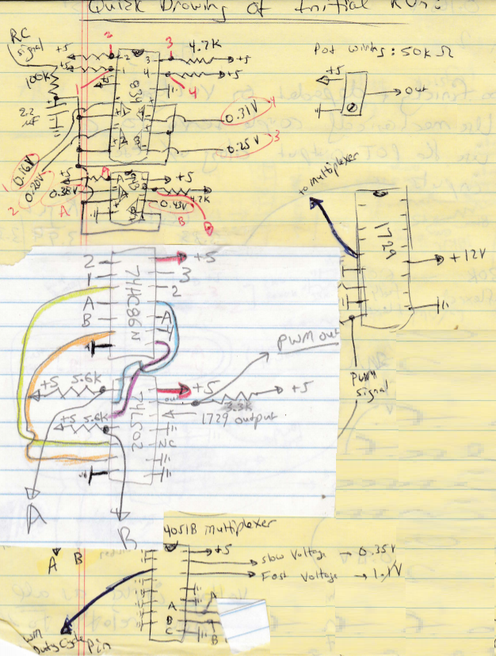

Figure : Wiring for Test Run

The comparator outputs (labelled 1-4, A, and B in Figure 13) are all pulled high and then wired into a quad XOR gate (74HC86N) to test for the four conditions which result in movement. We compare 1 and 2 (V > 0.16? and V > 0.20?) and A and B (V > 0.38? and V > 0.43?) which are the tests for FAST speed. An XOR output of HIGH for either condition indicates FAST speed, and is fed to a NOR gate which goes LOW if FAST is required. The low condition on pin 4 of the 74LS02 NOR connects to pin 10 or B on a 4051 multiplexer.

Similarly, we compare 2 and 3 (V > 0.20? and V > 0.25?) and A and 4 (V > 0.31? and V > 0.38?) which are the tests for SLOW speed. An XOR output of HIGH for either condition indicates SLOW speed, and is fed to a NOR gate which goes LOW if SLOW is required. The low condition on pin 1 of the 74LS02 NOR connects to pin 11 or A on a 4051 multiplexer.

Unless one of the XOR gates goes HIGH, the default for the multiplexer is ABC = 110, which is a stop condition. Of the seven test conditions in Figure 13, we only need to test four. The multiplexer input/output is summarized in Figure 16.

|  |  |  |  |
| --- | --- | --- | --- |
| Input Voltage | XOR Outputs | Multiplexer Input ABC | Multiplexer Output |
| V < 0.16  V > 0.43  0.25 < V < 0.31 | LOW | 110 | X3, Pin 12 |
| 0.16 < V < 0.20 | Pin 3 HIGH | 100 | X1, Pin 14 |
| 0.20 < V < 0.25 | Pin 11 HIGH | 010 | X2, Pin 15 |
| 0.31 < V < 0.38 | Pin 8 HIGH | 010 | X2, Pin 15 |
| 0.38 < V < 0.43 | Pin 6 HIGH | 100 | X1, Pin 14 |

Figure : Multiplexer Inputs and Outputs.

Testing showed that this worked okay, but with erratic behavior and lots of motor revving. Perhaps the voltage divisions were too close to each other… there is only about a 300mV range in voltages, and they are highly dependent upon variables including the supply voltage and any dropped pulses from the RC receiver. I ended up fixing this by mechanically coupling a servo to a potentiometer (see Mechanical Assembly).

My comparator setup could also be used to control the direction of motor rotation which was a LOT simpler than controlling the speed. The output from NTE834 pin 14 (comparator #3) switches the direction. At voltages above 0.25V, the motor is either stopped or spinning clockwise. Below that voltage, it’s either stopped or spinning counterclockwise. The Pololu MD03A uses two bits (INA/INB) to control braking and direction, with complements (eg 1/ 0 or 0/ 1) setting the direction. The output from pin 14 along with its complement (obtained by inverting it with a 2N7000 mosfet) are fed to the direction pins as shown in Figure 17.

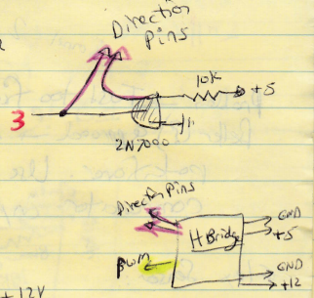

Figure : Direction Control

The final schematic for a single motor is shown in Figure 18. The input voltages have been adjusted to reflect the mechanical coupling of a servo to a potentiometer (see Mechanical Assembly). In the electrical assembly, this schematic was constructed twice (once for each motor) with two different RC inputs controlling the left and right motors. However, the reference voltage potentiometers (six pots in the bottom left) were the same for both motors. The range and center point of each input (RC) potentiometer were adjusted using the controls for the RC transmitter so they were the same.

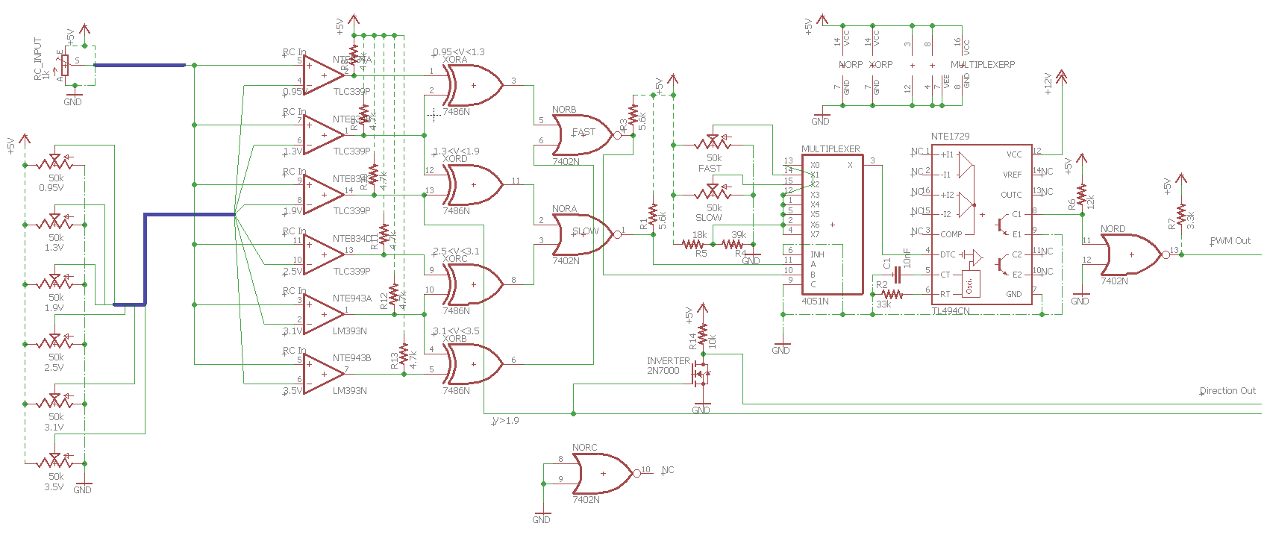

Figure : Final Schematic

One additional change was made; the PWM output from the NTE1729 was inverted by running through a 7402 NOR gate with the other input grounded. As mentioned in the section on Phase 1, the DTC control has a 0.1V minimum. This means that there is no way to get a zero duty cycle. However, a 100% duty cycle is possible at DTC ~ 3.3V. By inverting PWM, the motor is stopped at DTC = 3.3V and spinning faster at DTC = 0V. In practice, I just adjusted the slow/fast voltages for the multiplexer (pins 14/15, see Figure 15) so the motor went at reasonable speeds.

I also tied all the multiplexer inputs except X1 and X2 to a voltage of 3.3V, using a voltage divider as shown in Figure 19.

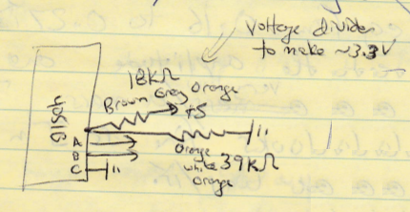

Figure : Voltage Divider for X3 input

Measured Values for 1729 Circuit:

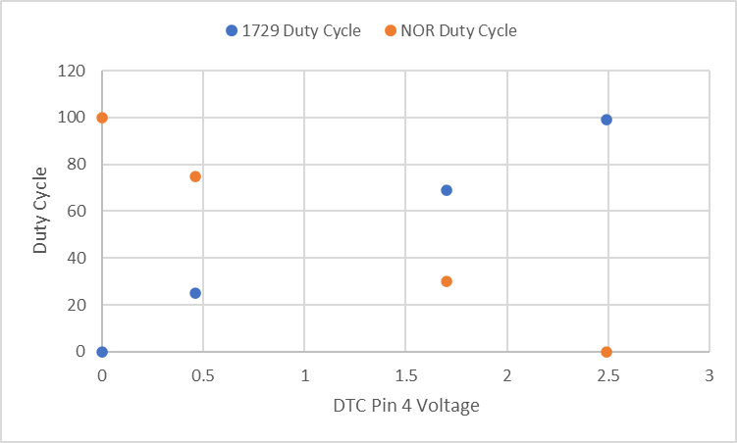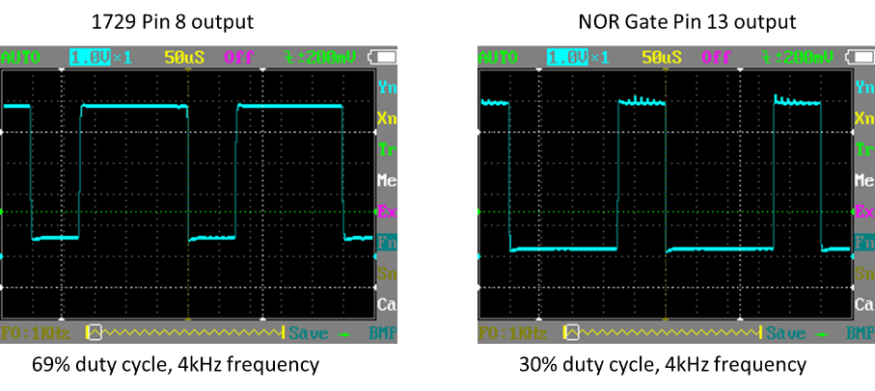

Effect of Pin 13 (Output Control):

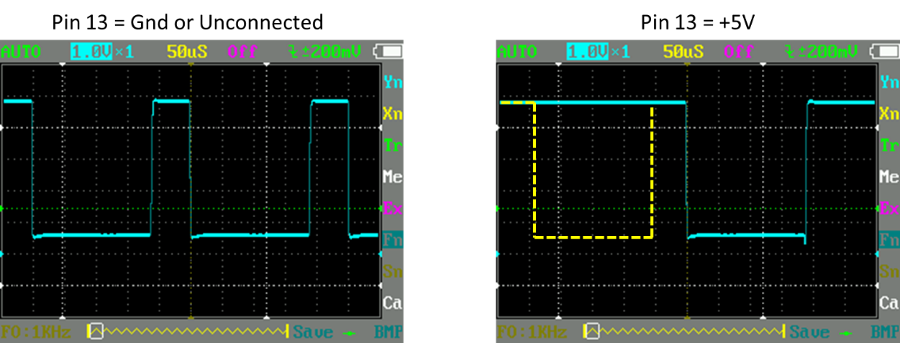

# Phase Three: Stepper Motor Controller

Recipe 13.5 in the Electronics Cookbook gives code for using a L293D chip to control a stepper motor. The sequence for energizing coils with this chip is shown below:

|  |  |
| --- | --- |
| Forward  Pins 2 7 10 15 | Reverse  Pins 2 7 10 15 |
| 1 0 0 1  1 0 1 0  0 1 1 0  0 1 0 1 | 0 1 0 1  0 1 1 0  1 0 1 0  1 0 0 1 |

Forward and reverse are just opposites of each other. My solution was to use a shift register to generate a repeating sequence and then decode that to the values above:

|  |  |
| --- | --- |
| Forward | Reverse |
| 1 0 0 0  0 1 0 0  0 0 1 0  0 0 0 1 | 0 0 0 1  0 0 1 0  0 1 0 0  1 0 0 0 |

The 74194 is a bidirectional, 4-bit shift register which can generate the values in the above table. Figure 20 shows a test setup.

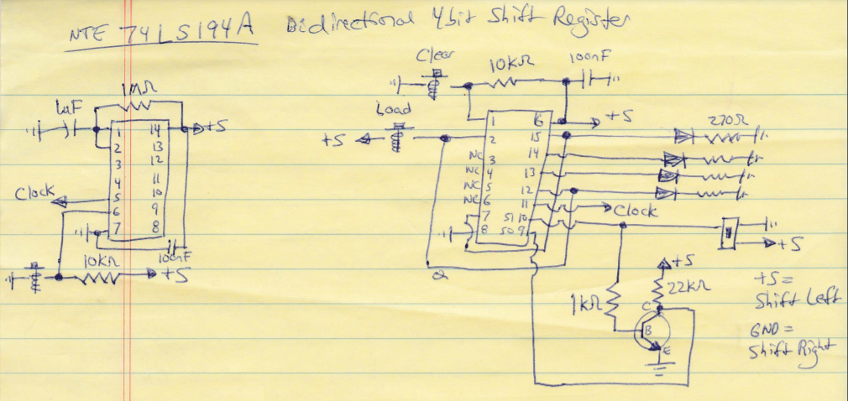

Figure : Bidirectional Shift Register Test

After power is applied, the shift register first needs to be cleared to set all four bits to zero. Then we “load” a high value onto QA (making 1000): while S1 is LOW and S0 is HIGH we set the Serial Right Input (pin 2) HIGH, and then pulse the clock. The HIGH value on the Serial Right Input is loaded to QA. The rightmost bit (QD = pin 12) is wired into the Serial Right Input so on the next clock pulse, the 0 on QD wraps around to QA (making 0100). Subsequent pulses generate the rest of the forward sequence.

To generate the reverse sequence, the leftmost bit (QA = pin 15) is wired into the Serial Left Input (pin 7). With S1 HIGH and S0 LOW, clock pulses shift all the bits left with QA wrapping around to become QD (example 1000 🡪 0001).

To decode the shift register sequence, I initially came up with a very complicated sequence as shown in Figure 21.

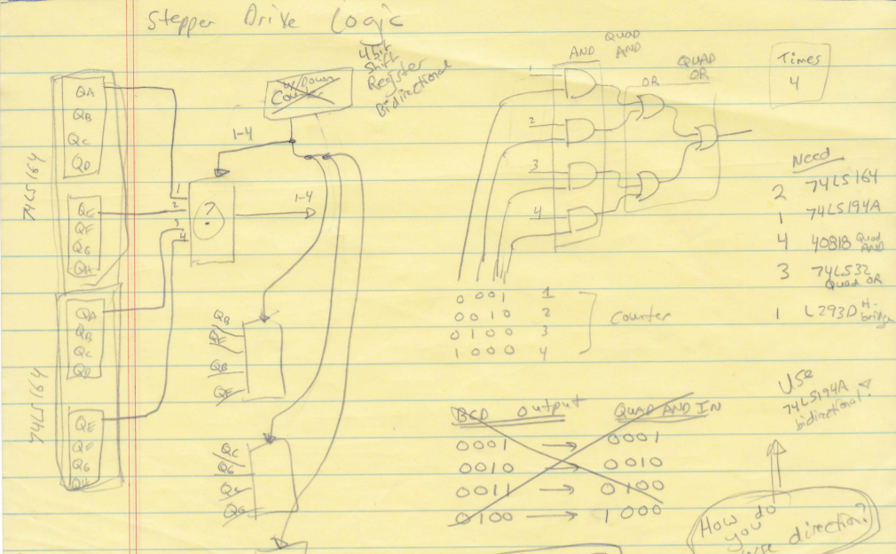However, this simplified drastically when all the AND gates which had permanent LOW values were removed. Figure 22 shows the simple decoder which is needed and the wiring for a test run with an actual stepper motor. Note that the rest of the wiring from Figure 20 is omitted (but was still present) in Figure 22.

Figure : Convoluted decoder.

The test worked, although the stepper motor I had drew way too much current overheating the H-bridge L293D (24V/600mA MOTS3 from Velleman). I ordered a replacement (Item #324, 12V/300mA) from Adafruit which worked great.

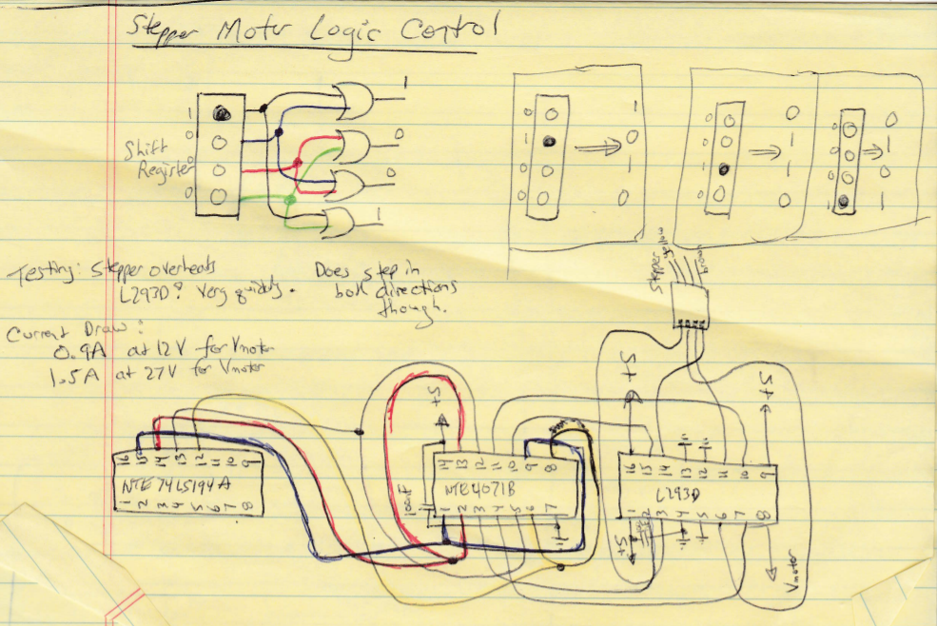

Figure : Actual decoder and stepper test wiring.

The next step was to replace the mechanical switches (clear/load/clock) with electronic control. I used four 555 timers; timer 1 clears the shift register (like the “Clear” button in Figure 20) and also starts the second and third timers when it ends. Timer two enables a tristate buffer which pulls the Serial Right Input on the shift register high. Timer two serves the same function as the “Load” button in Figure 20. A tristate buffer is required to disconnect the Serial Right Input once we’ve loaded the shift register (the tristate’s high impedance mode is like a released mechanical switch).

Timer 3 has half the duration of timer 2, and timer 3 starts timer 4 when it ends. Timer 4 sends a clock pulse to pin 11 on the shift register, loading a HIGH onto QA. Figure 23 shows the timer pulse (conceptually). Figure 24 shows the actual wiring for the timers. Now a single mechanical button (labelled Setup Button) initializes the stepper. In practice, this button doesn’t need to be pressed at all since the power-on condition triggers Timer 1 and the rest of the sequence anyhow.

Figure 24 contains some residual wiring/chips from an initial idea to run the stepper for a certain number of steps… the 7400 NAND latch and 4081 AND gates were discarded. The astable oscillator went on another board and the four timers were consolidated on two NTE978s. Figure 25 shows the final schematic for the stepper driver board.

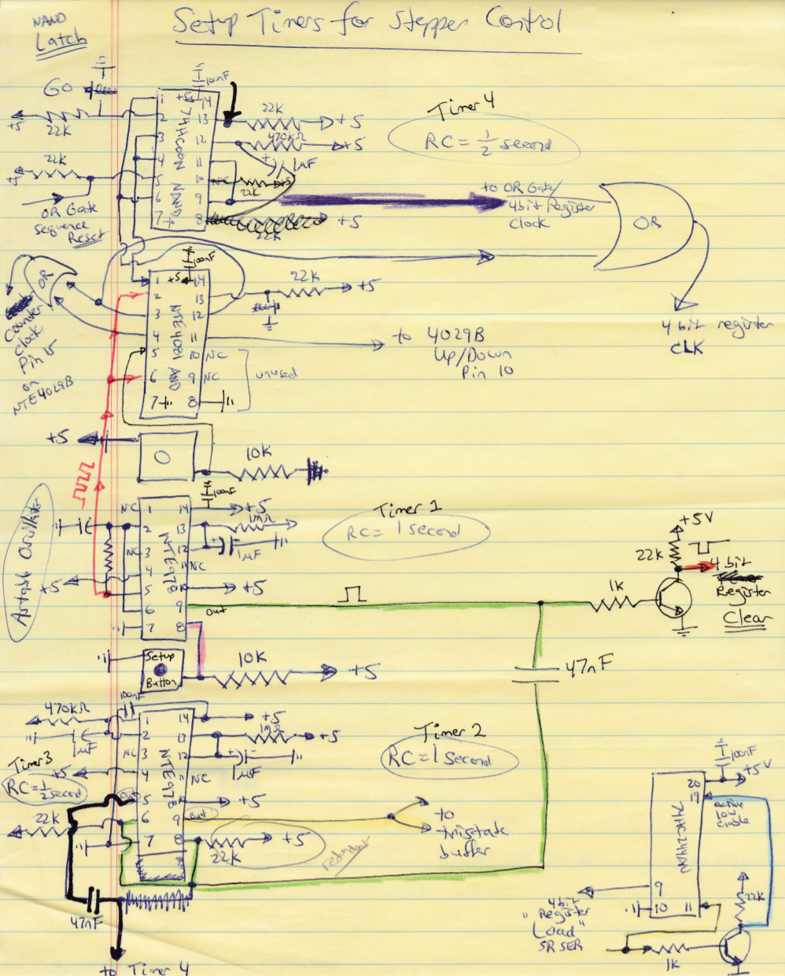

Figure 4: Timer wiring.

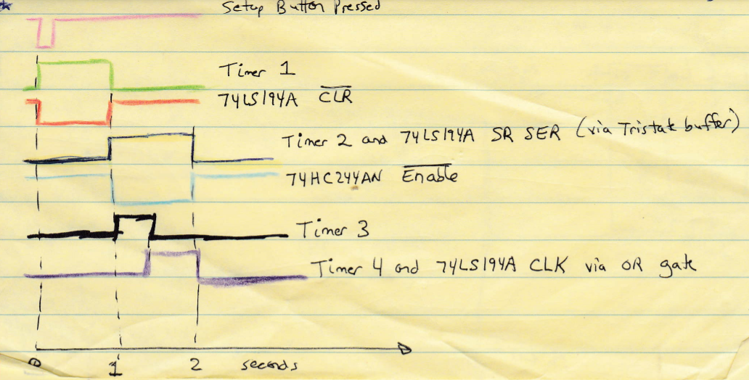

Figure : Reset timers.

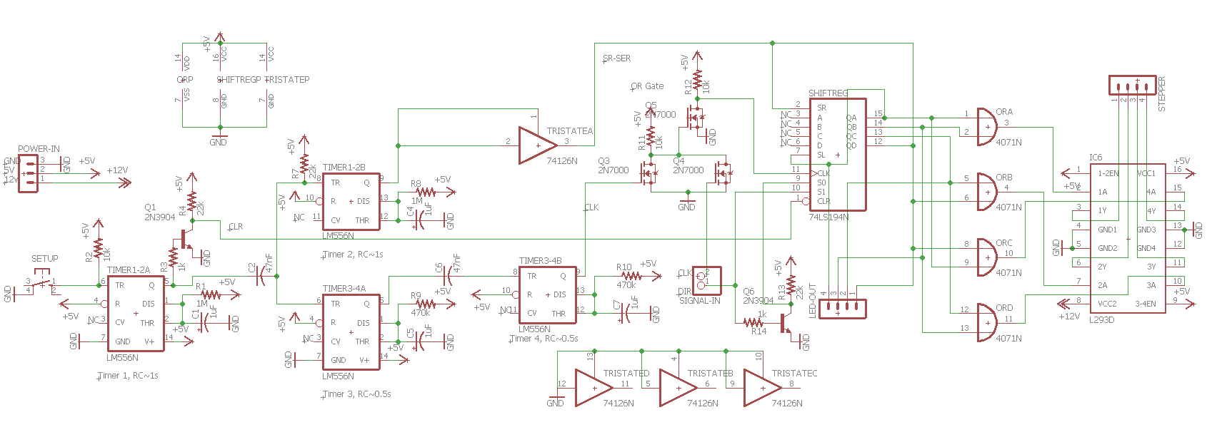

Figure : Final Stepper Schematic

# Phase Four: RC Control for Stepper Motor

The last electronic design task was to use the RC signal to control the stepper. Figure 26 shows a quick block diagram. Two comparators are used to compare the RC signal to low and high setpoints. The results are decoded to control the direction and stepping of the motor (whether the clock is applied to the shift register). Note that the stepper is not being used for position control; rather it’s an overqualified DC motor.

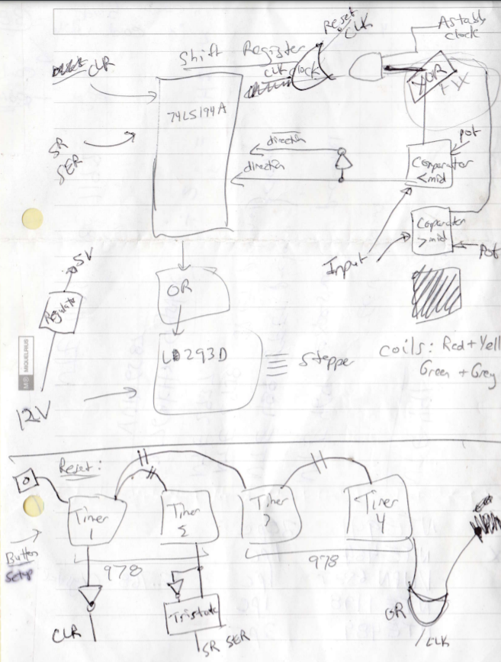

Figure : Block Diagram Overview

Figure 27 shows a sketch of the actual writing of the RC control portion of the circuit, and Figure 28 shows the schematic. The astable 555 oscillator (Electronics Cookbook 16.5) gives calculated output clock frequencies between $f=\frac{0.693}{RC}=\frac{0.693}{\left(54.7×{10}^{3}\right)\left(0.47×{10}^{-6}\right)}=27Hz$ and $f=\frac{0.693}{\left(4.7×{10}^{3}\right)\left(0.47×{10}^{-6}\right)}=313Hz$. The comparators work per the table below:

|  |  |  |  |
| --- | --- | --- | --- |
| Condition | Comparator A (pin 1) | Comparator B (pin 7) | XOR B (pin 4) |
| RC < 2 V | LOW | HIGH | HIGH |
| 2V < RC < 3V | LOW | LOW | LOW |
| RC > 3 V | HIGH | LOW | HIGH |

A comparator’s output is HIGH if the non-inverting (+) input exceeds the inverting (-) input. When the RC input is higher or lower than the deadband (2-3V), the XOR is high. This XOR output is ANDed (NAND + INVERTER) with the Astable Clock to suppress stepping in the deadband and allow it outside.

In addition, the individual comparator outputs are brought out as direction pins (buffered via two available XOR gates) which control S1 of the 74194A shift register.

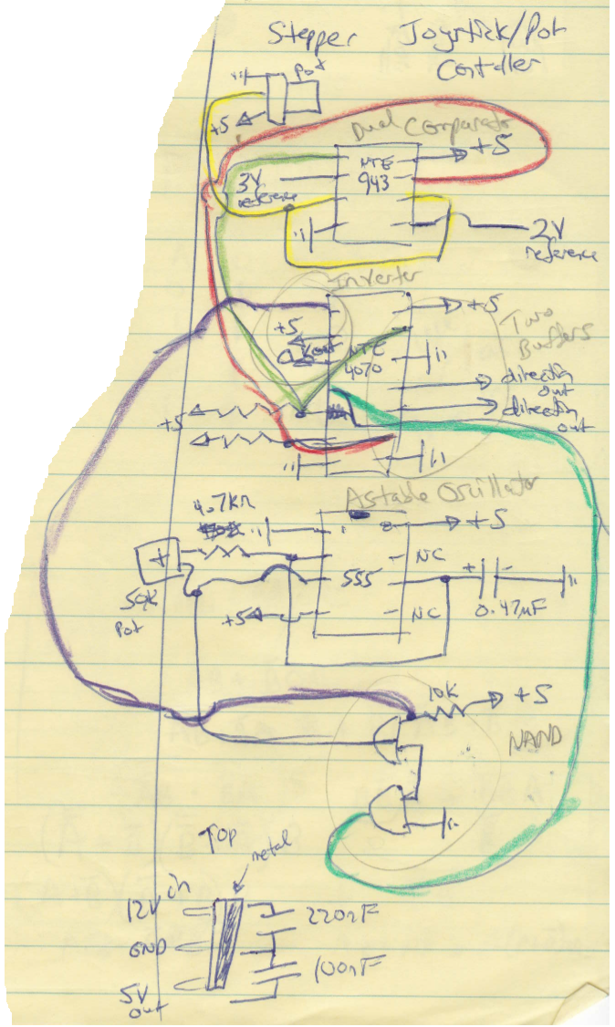

Figure : RC Stepper Control

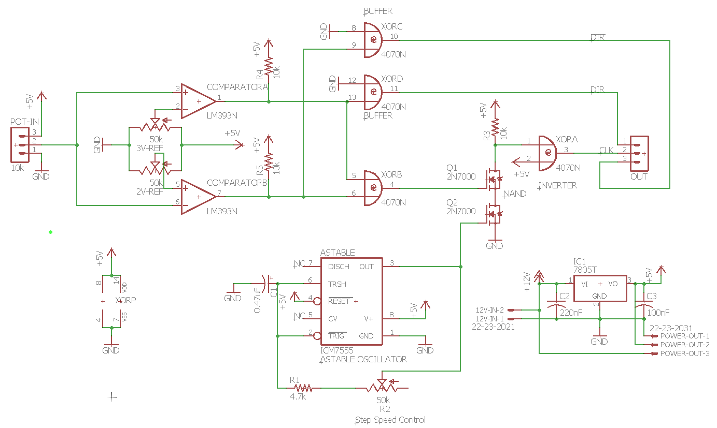

Figure : RC Stepper control schematic.

# Phase Five: Electrical Assembly

The motor controller circuits were assembled on four boards as shown below:

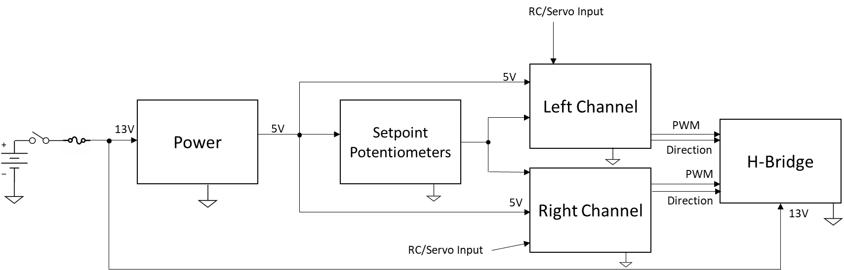

These boards were mounted in the belly of the chassis with the potentiometers for fast and slow speed control accessible on the front and rear openings.

The stepper controller was assembled on two boards, one for each of the schematics (Figures 25 and 28). These were sandwiched back-to-back and mounted standing up on top of the chassis.

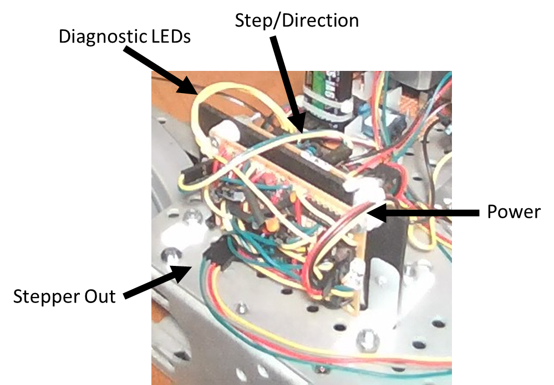

# Phase Six: Mechanical Assembly and Laser Pointer End Effector Mounting

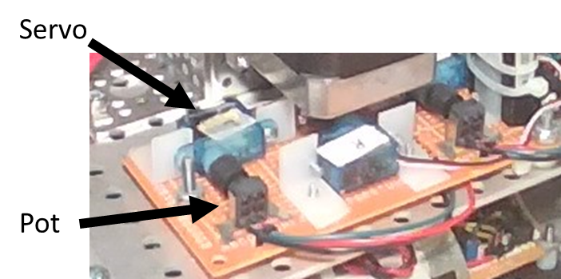I found it too difficult to use the raw PPM signal from the RC receiver to control the robot. Instead, I mechanically connected servos to electrically separate potentiometers. The pots were the control inputs for the drive motors and the stepper turret motor. I mounted micro sized servos on perf board using cheap drawer L brackets from a hardware store. I mounted potentiometers directly across from them, soldering the three pins into the perf board and using the metal wings to anchor the pots. I fitted a small rubber grommet (actually from a Covid era mask) over the shaft of the pot and the servo spline hub. The rubber is sandwiched in place and stretched enough to provide solid mechanical coupling. I soldered connecting wires to the potentiometer pins, and these were routed to the electronic control boards.

I wanted to put some type of end effector on the top of the robot, and chose a laser pointer. I purchased several components from Servo City to allow rotation and elevation of the pointer. A NEMA 17 mount holds the stepper and is attached via a sturdy 90o pattern mount to a U-channel. Inside the channel, two pillow blocks hold a 1” diameter tube which extends out the top. A pulley with 1” bore is sandwiched between a clamping hub and a pattern adaptor. The hub clamps onto the tube. A second, much smaller, pulley is attached to the stepper motor shaft, and a XL timing belt connects the two pulleys.

On top of the large pulley, a HS-645MG servo is mounted in a servo block with the laser pointer clamped to the servo horn. Two angle brackets attach the whole assembly to the chassis. A parts list is shown in Figure (**. Figure *** shows the labelled assembly.

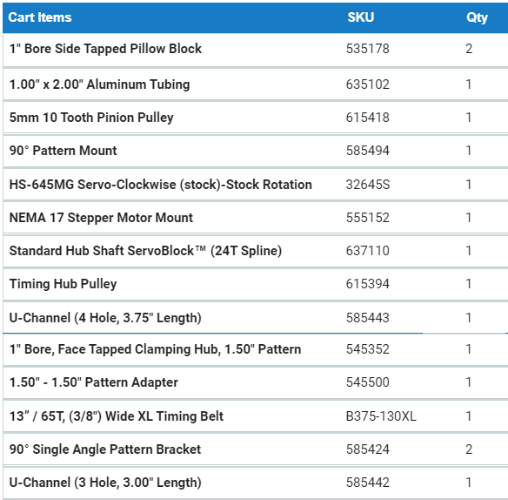

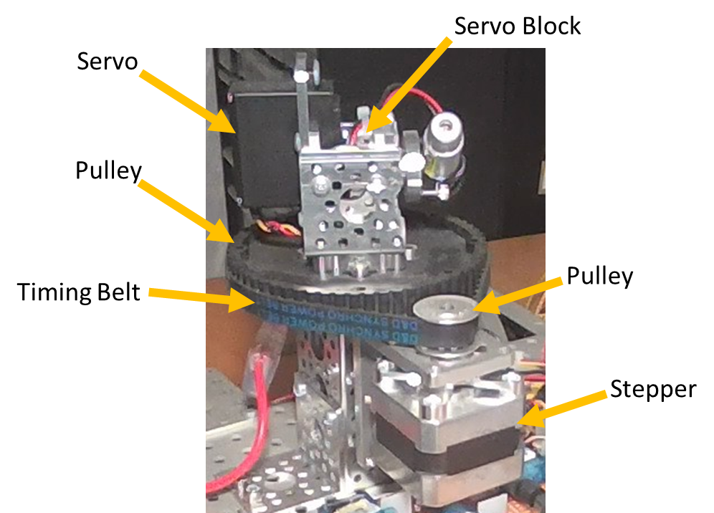

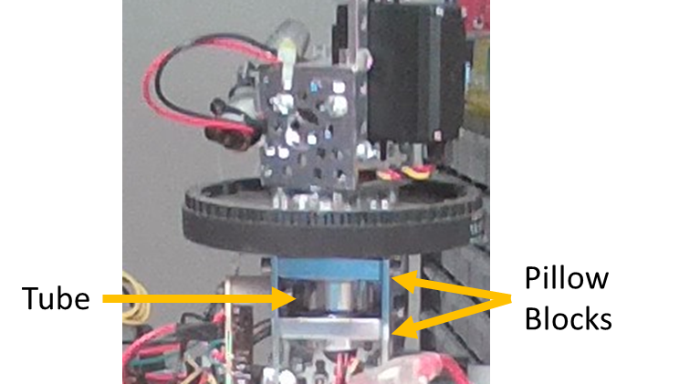

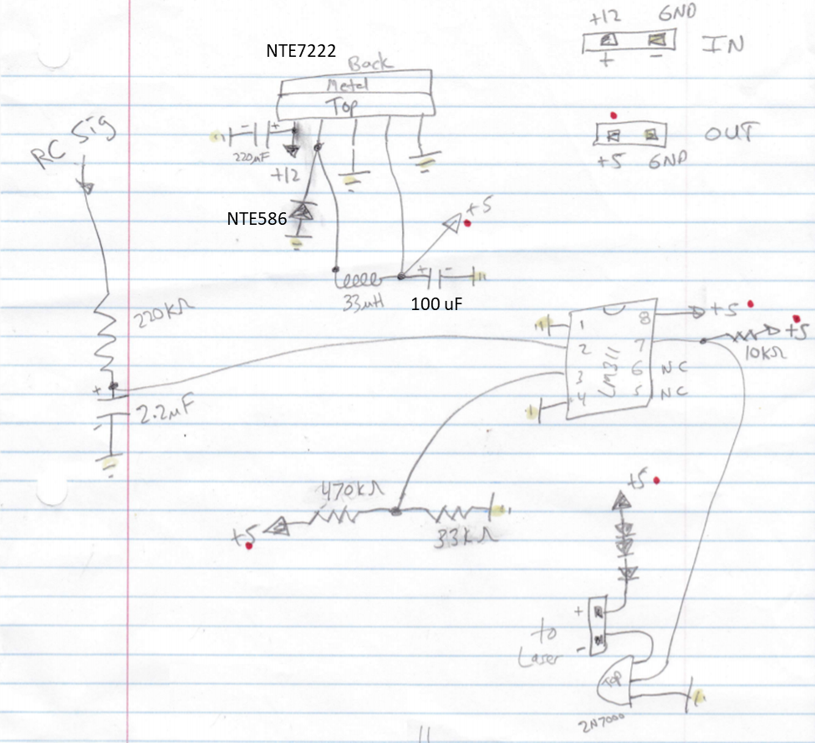I created an electronic control board for the laser pointer. This same board also provides power for the servos and the RC receiver. The HS-645MG servo can draw up 2.5A at stall, and the rest of the electronics is run from a 7805 which would overheat at that load. Instead, I used a buck regulator based on the NTE7222. The Electronics Cookbook gives the required schematic (recipe 7.8). The inductor was NOT rated for 3A as it should be, but it’s working fine since the actual HS-645MG servo load is small.

A fifth channel of the RC receiver is used to turn on and off the laser. The output is filtered and compared to a threshold using a LM311. The voltage to the laser is dropped by a couple volts using three series diodes. The board takes 12V power as the input and powers the RC receiver (which powers all four servos) via a 5V connection. The completed board is shown below.

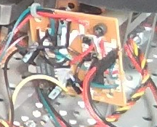

The final modifications needed for this project were to the RC transmitter. Instead of using tank drive, which would tie up both joysticks, I rotated one joystick by 45 degrees and used both channels of that joystick to drive the robot. Pushing forward moves the robot forward, down backwards, right turns it clockwise, and left turns counterclockwise. The left joystick was then used to control the laser pointer, with forward pointing the laser up, backwards down, right spinning the turret clockwise, and left spinning the turret counterclockwise. The top right switch turns the laser pointer on and off.

RC Settings:

|  |  |  |  |  |  |
| --- | --- | --- | --- | --- | --- |
| Channel | Function | Reversed? | Left Endpoint | Right Endpoint | Subtrim |
| 1 | Right Motor | Yes | 100% | 100% | ¼ to right |
| 2 | Left Motor | No | 100% | 60% | ¾ to left |
| 3 | Laser Elevate | No | 71% | 120% |  |
| 4 | Laser Rotate | No | 100% | 100% | 0 |
| 6 | Laser On/Off |  |  |  |  |

